**Enhancement Two: Algorithms and Data Structure**

**CS-499 Computer Science Capstone**

**Juan Topete**

**06/09/2024**

The second artifact I choose to enhance for the Algorithms and Data Structure category is the Pet Check-in/Check-out Service I have done for IT-145. In this project I explored the Java programming language to create a simple dashboard for pet grooming services. It utilized multiple *IF-Else* statements which were new to me at the time. The original code did not utilize a data structure for the menu or variables of the project. The flowchart for the project is shown below.

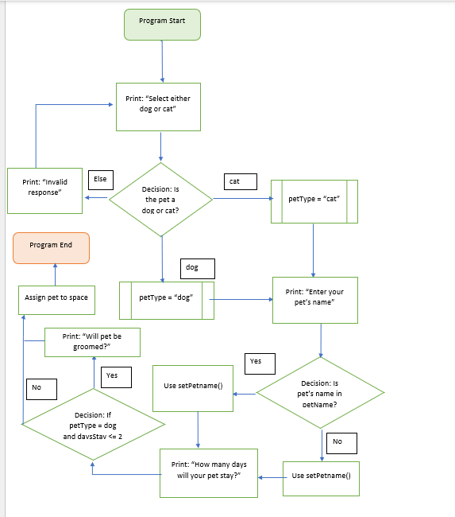

I selected this artifact as I could improve it considerably by implementing a new dashboard and using different data structures for its data. I decided to use an array as it could contain a list of different strings that can be edited and quickly move around for efficiency. I added the feature of selecting what name you wanted to give your pet and the ability to delete or modify the name once it is selected. For the user menu I used a *switch* statement which replaces the many if-else statements in the original code. It was now easier to interpret the intent of the application with the improved structure. I wanted to add a way for the user to login to the application, but I did not get around to implementing it.

The updates have made this feel more like a complete application. The use of arrays makes it faster to process multiple applicants at the same time. I feel I succeed in effectively communicating to the audience that I am targeting. I still plan to include the login feature for the submission of the ePortfolio as it would add a layer of security to the project.